Sample Manual (Rule Book) for Evacuation Shelter Set-Up and Management
- Disaster Edition ・
○○○ Evacuation Shelter

＊＊＊＊＊＊＊＊＊＊＊＊＊＊＊＊＊＊＊＊＊＊＊＊＊＊＊＊＊＊＊＊＊＊＊＊＊

This is a collection of a variety of rules that need to be followed when taking shelter at an evacuation center during disasters.

＊＊＊＊＊＊＊＊＊＊＊＊＊＊＊＊＊＊＊＊＊＊＊＊＊＊＊＊＊＊＊＊＊＊＊＊＊

July 2018
Revised April 2022

Disaster Prevention Division
Crisis Management Department
General Affairs Bureau, City of Chiba
避難所開設・運営マニュアル例（ルール集）【英語】

Table of Contents

1 Rules for Life at an Evacuation Shelter (Sample)……………………………………1

2 Rules for Using Public Phones during Disasters (Sample)…………………………2

3 Rules for Entering and Leaving an Evacuation Center (Sample)……………………………3

4 Rules for Using the Restroom (Sample)…………………………………………………………4

5 Rules for Using Fire (Sample)…………………………………………………………10

6 Rules for Pet Care (Sample)…………………………………………………………11

7 Rules for Maintaining a Hygienic Environment (Sample)……………………………………12

8 Rules for Distributing Supplies (Sample)………………………………………………………13

9 Rules for Nursing and Changing Diapers (Sample)…………………………………………14

10 To Those Staying at the Designated Evacuation Spaces (Sample)………………………15

Rules for Life at an Evacuation Shelter (Sample)

Rules for Living at ○○ Evacuation Shelter (finalized / / )
○○ Evacuation Shelter Staff
To operate this evacuation shelter, all relevant persons must understand that evacuees are living here temporarily due to shared hardship. We must all encourage and cooperate with each other to make life even just a little bit easier.
We ask that you comply with the following countermeasures and rules of the shelter.
Infection Prevention Measures
- Wear a mask.
- Ventilate the area at least twice every hour for a few minutes each time.
- Avoid the Three 3Cs (closed/crowded/close-contact spaces), follow coughing etiquette, and thoroughly disinfect your hands.
- There are separate spaces and bathrooms for people who develop a fever or other symptoms. Do NOT enter these areas without permission.
- Disinfect your hands after touching any communal item.
- Anybody who feels unwell must notify a staff at the evacuation shelter.

1 Do not enter areas you are not allowed to use.

2 Obey the instructions of the staff, section leaders, and group leaders, and refrain from rash behavior.

3 Each group elects a leader and assistant leader.

4 Those who are able to do so work in “sections” and follow the instructions of section leaders to help with evacuation shelter operations.

5 Alert reception when you first move into the evacuation shelter, and again when you move out.

6 Food and other supplies are distributed to each group (ex: at the gymnasium entrance).

7 Be sure to wear your nametag when you receive food and other supplies.

8 About the toilets:
(1) After using the toilet, flush using the (pool) water from the bucket.
(2) Cleaning and filling the water bucket are assigned duties.
(3) Cleaning times are 10AM and 5PM.

9 About waste disposal:
(1) Separate the waste and dispose of it in the designated place at the designated time. Do not dispose of anything in any other place.
(2) Cleaning the collection area is an assigned duty.
(3) Cleaning times are 10AM and 5PM.

10 Each information bulletin is posted for one week.

11 Lights are turned off at 10PM. Hallways lights are kept on.

12 Do not talk on the phone at your living area after the lights are turned off.

13 Do not have loud conversations after the lights are turned off.

14 Pet care (including water and food) is the responsibility of the owner (or the owner’s group) and must be done in a designated area. (*an area designated by the evacuation shelter staff)

15 Drinking alcohol is banned outside of the designated areas.

16 No smoking allowed anywhere on the premises.
17 Slander or abuse such as condemning individuals who become ill (and/or their relatives), or discrimination based on misinformation or prejudice will not be tolerated.
18 Always stay calm and rational, do not take any dubious or false information at face value, and do not spread misinformation.
避難所生活のルール（例）【英語】
Rules for Using Public Phones during Disasters (Sample)

Disaster-use public phones are free public phones that can be used by evacuees to, for example, relay their safety. They can be used even when regular phone lines cannot, and are less subject to transmission regulations. (These phones can only make calls. They cannot receive calls.)
Please use the phones according to the following rules.
Infection Prevention Measures
- Wear a mask when speaking on the phone.
- Disinfect your hands before talking on the phone.
- After talking on the phone, wash your hands thoroughly.
- Additionally, disinfect the handset and the dial buttons after using the phone.

* Please avoid using these phones except in case of emergency (checking your family’s safety, etc.)

* Other people also want to use the phone, so please do not talk for a long time. (Standard is 5 minutes or less.)

* Please refrain from behavior that would disturb other evacuees, such as talking in a loud voice.

* Please avoid using these phones after lights-out.

災害時用公衆電話の使用ルール（例）【英語】
Rules for Entering and Leaving an Evacuation Center (Sample)

For New Evacuees
Infection Prevention Measures
- If your home is located outside of a danger zone and you are able to secure your safety at your home, please consider taking shelter there instead of evacuating to a shelter. We can arrange to distribute supplies to you if you tell the reception desk that you will be taking shelter at home.
- Please consider taking shelter a friend’s or relative’s house, if they live in a safe location.
- When evacuating, in addition to food and drink, try to bring your own masks, disinfectant, and thermometer(s).
- The capacity limit at designated evacuation shelters has been greatly reduced. If the evacuation site you are currently in is over-capacity and a person requiring assistance evacuates to the shelter, you may be asked to relocate to a nearby shelter that still has availability.

When you enter the evacuation shelter

① After checking that you are wearing a mask and disinfecting your hands, you will get your temperature checked, and you will record the temperature on the “Health Monitoring Checklist” form.
*Keep the Health Monitoring Checklist form even after your admission to the shelter. Each evacuee should continue monitoring and recording their temperature every morning.

② At reception, fill out the “Evacuee Card” and hand it in.

③ Take your nametag.

④ Check the rules for living at the evacuation shelter posted on the information bulletin board.

⑤ You will be shown to your living space.

When you leave the evacuation shelter
① Please clean your living space. (Dispose of waste at the collection space or take it with you when you leave.)
If you are physically unable to clean your space, please consult your group leader or shelter staff.

② Please fill out the “Leaving Evacuation Shelter Notice” and submit to staff.
入退所のルール（例）【英語】
Rules for Using the Restroom (Sample)

1 Using the evacuation shelter facility’s restroom
- When using the bucket water

* People who have trouble standing or require assistance have priority use of Western-style toilets. Others are asked to use the Japanese-style toilet first.

* Toilet paper might plug the toilet, so throw it in the waste basket instead of flushing it. Be sure to close the basket lid after throwing away toilet paper to prevent the odor from spreading.

* After using the toilet, use the bucket water to flush.

* This is everyone’s toilet, so please keep it clean.

* Do not use the bucket water to wash your hands.
Please wash your hands with the hand-washing water, as well as the provided disinfectant alcohol.

* Filling the bucket water and cleaning the restrooms are tasks done by all evacuees on an assigned basis.
These duties are assigned by group, so please check the on-duty chart and cooperate on these tasks.
If the water and/or toilet paper is running low, replace it yourself regardless of who is on-duty.
トイレ使用ルール（例）
避難所施設のトイレを使用する場合
ア 汲み置きの水を使用する場合【英語】
Rules for Using the Restroom (Sample)

1 Using the evacuation shelter facility’s restroom
B) When using a portable toilet

＊ Please use the portable toilet according the explanation on the separate page.

＊ This is everyone’s toilet, so please keep it clean

＊ Please wash your hands with the hand-washing water, as well as the provided disinfectant alcohol.

＊ Cleaning the restrooms is done by all evacuees on an assigned basis.
These duties are assigned by group, so please check the on-duty chart and cooperate on these tasks.

How to Use a Portable Toilet
トイレ使用ルール（例）
避難所施設のトイレを使用する場合
イ 携帯トイレを使用する場合【英語】
Please refer to following instructions on how to use portable toilet if one is placed in a Western-style bathroom.
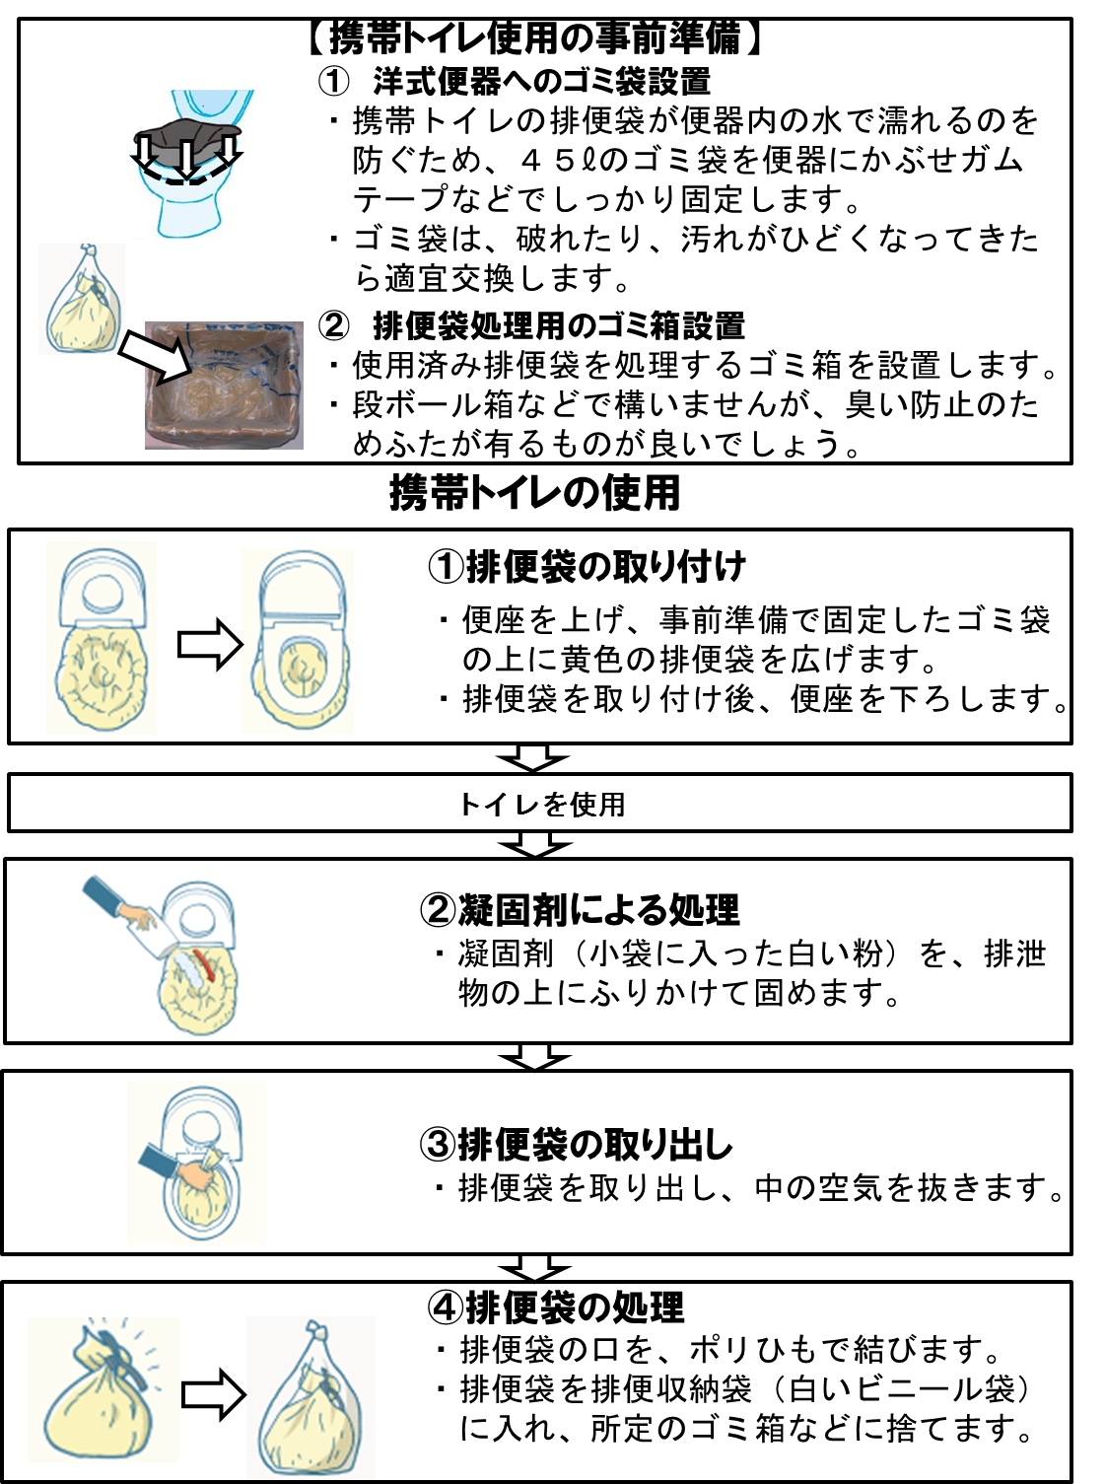
4) Dispose of the toilet bag
・Use plastic twine to close the toilet bag.
・Place the toilet bag into a waste storage bag (white plastic bag), and throw it away in its appropriate garbage bin.
To be prepare in advanced:
- Placing a garbage bag inside the toilet
・To prevent the toilet bag getting wet with water, place a large 45l garbage bag inside the toilet and secure it down with tape (or similar).
・Replace the garbage bag accordingly when it becomes soiled or torn.
- Garbage bin to throw away used toilet bags
・Place a garbage bin/box to throw away used toilet bags.
・It can be made of cardboard or similar material, but it would be best to use something with a lid to prevent odour from spreading.
3) Remove the toilet bag
・Take the toilet bag out of the toilet, and remove any air inside.
2) Add coagulant
・Use the coagulant (the white powder inside the small bag) and sprinkle it over the waste material.
- Install the toilet bag
・Lift the toilet seat and place a yellow toilet bag over the garbage bag you prepared beforehand and fixed down with tape.
・After installing the toilet bag, lower the toilet seat.
Using the Toilet
Using the Portable Toilet
携帯トイレ使用方法【英語】
Rules for Using the Restroom (Sample)

1 Using the evacuation shelter facility’s restrooms
C) When using a simple toilet

* This is everyone’s toilet, so please keep it clean.

* Please wash your hands with the hand-washing water, as well as the provided disinfectant alcohol.

* Cleaning the restrooms is done by all evacuees on an assigned basis.
These duties are assigned by group, so please check the on-duty chart and cooperate on these tasks.

* Please use the simple toilet in conjunction with the portable toilet.

* If the sanitary waste bag becomes full, whoever finds it that way should change it regardless of who is on duty.
Standard Bag Changing…Install it into the toilet bowl, and change it after it becomes about 30% full.

トイレ使用ルール（例）
避難所施設のトイレを使用する場合
ウ 簡易トイレを使用する場合【英語】
Rules for Using the Restroom (Sample)

2 When using a manhole toilet

* Check if someone is already inside before using the restroom.

* When using the restroom, switch the sign at the entrance to “Occupied” so that other people know it’s in-use.

* This is everyone’s toilet, so please keep it clean.

＊ Please wash your hands with the hand-washing water, as well as disinfectant alcohol.

＊ Cleaning the restrooms is done by all evacuees on an assigned basis.
Also, bad odor or plugging may occur if the water is not flushed periodically, so flushing is also an assigned task.
These duties are assigned by group, so please check the on-duty chart and cooperate on these tasks.
Standard Flushing・・・flush the water once every hour (excludes periods when toilet is used infrequently, such as nighttime)

トイレ使用ルール（例）
マンホールトイレを使用する場合【英語】
Rules for Using the Restroom (Sample)

3 Using a temporary toilet

* Check if someone is already inside before using the restroom.

* When using the restroom, switch the sign at the entrance to “Occupied” so that other people know it’s in-use.

* People who have trouble standing or require assistance have priority use of Western-style toilets. Others are asked to use the Japanese-style toilet first.

* This is everyone’s toilet, so please keep it clean.

* Please wash your hands with the hand-washing water, as well as provided disinfectant alcohol.

* Cleaning the restrooms is done by all evacuees on an assigned basis.
These duties are assigned by group, so please check the on-duty chart and cooperate on these tasks.

* This toilet requires a professional to unplug it, so whoever finds discovers the toilet is plugged should alert the Facility Section.

トイレ使用ルール（例）
仮設トイレを使用する場合【英語】
Rules for Using Fire (Sample)

* Open flames at the evacuation shelter are primarily limited to the ( ) room and the ( ) outdoor area.
・ Do not use fire in the living space.
・ Personal portable stoves must also be used in the ( ) room.

* Please don’t use fire inside the shelter at night (after ____:____).
If you need to use it, please notify the General Affairs Section.

* Check with the General Affairs Section and facility manager before using items like space heaters in the living space.

* Don’t place flammable items near a space heater.

* Alert the General Affairs Section before replacing the space heater’s fuel.

火気使用ルール（例）【英語】
Rules for Pet Care (Sample)
Attention Pet Owners:
At evacuation shelters, owners bear responsibility for the care and management of their pets based on the following rules.
① Keep your pet in a cage or tied to a pole in the designated care area.
Follow the shelter staff’s instructions about where you can keep cages or tie up pets.
You are not allowed to take care of your pet outside of the designated pet care area.
* There may be people in the shelter with pet allergies, people who feel uncomfortable around animals, children who may suddenly try to touch them, etc. Out of consideration for these people, you are not allowed to take your pet outside of the care space (such as to the living area, etc.).
However, assistance dogs (guide dogs, hearing dogs, service dogs) for those with disabilities are not considered pets, and in accordance with the “Act on assistance dogs for physically disabled persons,” may accompany their handler in communal spaces.
② The following animals are allowed to stay at evacuation shelters:
Small animals such as cats and dogs
(Animals that might harm people or require special care are not allowed.)
③ All required work related to pet care will be done on a cooperative basis by the owners.
- Care environment management done by the owners’ group (collaborative)
A Create an owners’ group.
B Establish and set-up a place for pet care.
C Make a pet management chart.
D Check the pet care rules, and decide a work schedule as a group.
E The group will handle tasks that can be shared.
- Care/management done by each owner (individual)
A Food, water, and cleaning up leftovers
B Walks, grooming
C Cleaning inside/outside of cages and the surrounding area and more.
*Normally, items needed for pet care and managements (cages, other tools) and pet food are provided by each pet’s owner.
④ Please feed your pet at the decided time and clean up after.
Maintaining a clean pet, cage, and care environment makes life better for everyone at the shelter.
⑤ Have your pet use the restroom in the designated place, and do the appropriate clean up after.
(Please be careful, as inappropriate pet waste disposal is a cause of complaints even in regular living situations.)
⑥ Please do walks and grooming outside the shelter or in the designated place inside the shelter.
Prevent trouble when moving or going on a walk by using a leash or briefly carrying your pet.
Manage hygiene and health to prevent fleas and ticks.
⑦ Sometimes owners cannot care for their pets at shelters due to injury. Please cooperate as a group and help each other with pet management.
⑧ Please make an effort to prevent pet-related complaints and injuries.
⑨ Consider having your pet temporarily stay with a relative or friend.
Staying at an evacuation shelter long-term only increases stress for you and your pet, so consider methods to decrease that stress.
ペット飼育ルール（例）【英語】
*Altered from Chiba City’s “Evacuation Shelter Procedures Regarding Pet Care”
Rules for Maintaining a Hygienic Environment (Sample)

* Wash your hands frequently. In particular, wash your hands before eating and after using the restroom. Use disinfectant to disinfect.

* Wear a mask whenever possible.

* In addition to following coughing etiquette and hand-washing, make a conscious effort to avoid the 3Cs (closed spaces, crowded places, close-contact settings).

* Ventilate your area at least twice an hour, for a few minutes each time.

* Washrooms and living spaces are specially prepared for people who develop symptoms such as fever or cough; their areas and movement routes are separate.

* When you help distribute supplies/food, first check if you have any symptoms outlined on the Health Monitoring Checklist (take your temperature, check for fatigue or shortness of breath) or if you have any digestion issues such as diarrhea or vomiting/nausea. Furthermore, be sure to wash and disinfect your hands as well as to put on rubber gloves and a mask when working.

* Avoid sharing towels with others.

* When taking off your mask to eat, speak as little as possible with others around you.

* For bagged foods, eat them directly from the bag without breaking them into smaller pieces with your hands.

* To prevent droplets hitting others, keep a distance of 2m or farther from other evacuees, and sit down facing away from each other.

* Please change into indoor/outdoor shoes when entering/leaving the facility. Prepare separate shoes to wear when using the bathrooms indoors.

* Please cooperate with the other evacuees and determine a rotation-based cleaning schedule.

* Should anybody start vomiting, please clean up the area using disinfectant or chlorine bleach. Clothes that have been sullied with vomit are a source of infection; remove these clothes, place them in a plastic bag, and dispose of them or clean them as necessary.

* If you develop a fever of 37.5°C or higher, or feel extremely fatigued or short of breath, immediately alert a staff member at the evacuation shelter. Likewise, if you to develop a cough, vomit, persistent diarrhea, etc. and suspect that you have contracted something, do not hesitate to report as such to a staff member.
衛生環境保持のためのルール（例）【英語】
Rules for Distributing Supplies (Sample)

Infection Prevention Measures
- Stagger your eating times to avoid crowding and close contact with others.
- When distributing supplies such as foodstuff or water, they will be distributed to you by being placed on a table or through other indirect manners to avoid directly handing them to you.

* Supplies such as food and water will be distributed evenly.
However, if there is a limited supply, the elderly, disabled, pregnant/nursing, babies/toddlers, and children will be prioritized.

* Supplies are handed to each group, so please distribute among the members of your group.

* People staying at home or in their cars to evacuate must register before receiving supplies. You cannot receive supplies if you have not registered.

* Supplies are usually distributed at around ( : ) each day, and distributed by the Food Section or Supplies Section at the ( ). Please maintain order when receiving supplies.

* Be sure to wash your hands or clean with disinfectant before distributing or receiving food.

* Sometimes allergen ingredients may be present in the food items. Those who desire allergy-safe foods should speak to the Food Section as far in advance as possible.

* Please tell the Supplies Section if you need something.
物資配給ルール（例）【英語】
Rules for Nursing and Changing Diapers (Sample)

* Nursing and diaper-changing areas are set up in ( ). Please use them as needed.

* Before using the room, check if someone is already inside.

* Men cannot enter the nursing area.

* Please put used diapers into a small plastic bag before disposing at the designated site to prevent odor and maintain cleanliness.
授乳及びおむつ替えルール（例）【英語】
To Those Staying at the Designated Evacuation Spaces (Sample)

Thank you for your cooperating with infection prevention measures at the evacuation shelter. We ask that you comply with the following rules when staying at the designated evacuation spaces.

- Make sure you have filled out and made an Evacuee Card.
- Immediately tell an evacuation shelter staff if your condition worsens.
- You must monitor your health condition yourself every morning.
- Ventilate the area periodically (twice every hour for a few minutes).
- You will mainly be staying within your designated living area. If you must go outside of it, please inform a shelter staff member. Wear a mask, keep appropriate physical distance from others (2m or more) and avoid coming into direct contact with other people as much as possible. When returning to your living area, you must wash your hands or disinfect them with sanitizer.
- Do not use any other restroom beside the designated rest room. After using it, please clean the toilet and the area.
- You are responsible for maintaining your living area clean.
- Please sort your garbage appropriately and dispose of it in its appropriate bin.
- Do not have face-to-face meetings with any visitors to the area.
- When it comes time for you to leave the shelter, please consult with an evacuation shelter staff member beforehand.
- You are required to follow all instructions from the shelter staff members during your stay at the evacuation shelter.

専用避難スペースで生活されている方へ（例）【英語】

